BIT 4107 – Mobile Application Development
ENHANCED PROFESSIONAL STUDENT LOGBOOK
Student Name: Issa Hafif
Admission Number: BIT/2024/52570
School/Faculty: School of Computing and Informatics
Programme: Bachelor of Science in Information Technology
Academic Year: 2026/2027
Semester: May/August
Lecturer: Mr. Nyoro
Phone Number: 0710408477

Contents
WEEK 1: Introduction to Mobile Application Development 3
Installing the development tools 3
1.Android studio 3
2.Visual Studio Code 3
Configuring development environment 3
1.Android studio (SDK) 3
2.Flutter 5
Creating the first mobile app 7
Personal Reflection 9
Week 2: Programming Languages and Frameworks 10
Flutter project (Mini Student Management App) 10
1.Frameworks(figma) 10
2.Screenshots (Actual App) 11
Personal Reflection 12
Week 3: User Interface (UI) Development 13
Building a complete UI 13
1.Frameworks (figma) 13
2.Screenshots (Actual App) 15
Database Intergration(SQLite) 18
Firebase 20
Personal Reflection 21
Week 4: Event handling and User interaction 22
Login button 22
Registration button 23
Add button 24
Confirm button 25
Personal Reflection 25
Week 5: Data Management 26
1.Adding a product/item 26
2.Updating product/item quantity 27
Adding a product 27
Reducing a product stock 28
Stored transactions 29
Personal Reflection 30
Week 6: Networking 31
Application Launch Interface 31
User Interface Layout Design 33
Item layout design for RecyclerView 34
RecyclerView adapter implementation 35
Local data testing output 36
Internet permission configuration 37
Retrofit dependency setup 38
API model structure 39
API interface definition 40
Asynchronous API Request Handling 42
Final API data output 43
Technologies Used 44
Why my app requires networking? 44
Personal Reflection 44
Week 7: Application architecture 45
Personal Reflection 45

WEEK 1: Introduction to Mobile Application Development

Installing the development tools

1.Android studio
From the website (https://developer.android.com/studio), download.
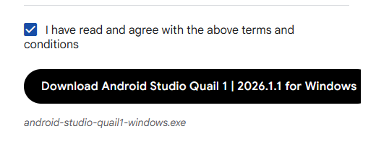
Figure 1

2.Visual Studio Code
From the website(https://code.visualstudio.com), download.
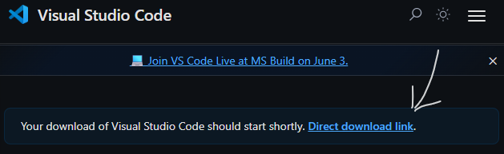
Figure 2

Configuring development environment

1.Android studio (SDK)
SDK Platform
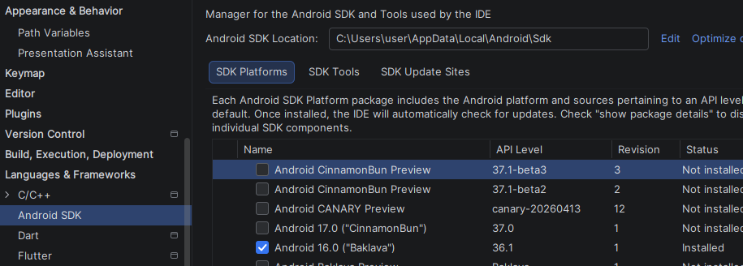
Figure 3

SDK tools
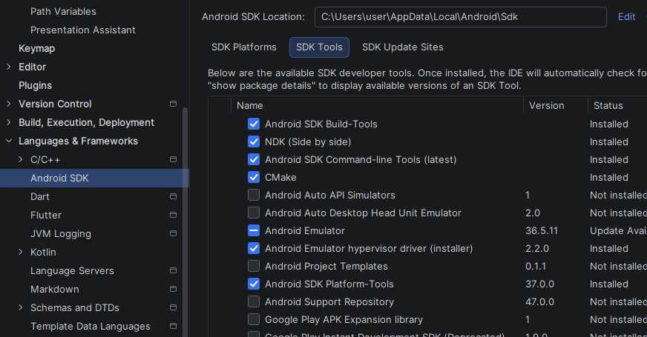
Figure 4
Emulator
From device manager, add a virtual device (create a virtual device), select a device (e.g., Pixel 2) and download.
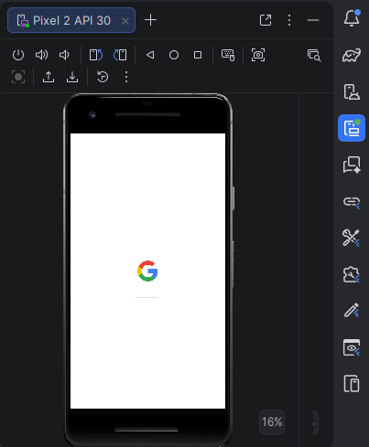
Figure 5

2.Flutter
Installing flutter, dart, GitHub Copilot extensions.
-Flutter comes with dart.
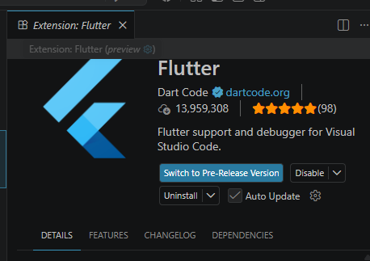
Figure 6

-Since GitHub Copilot is deprecated, we will use the chat
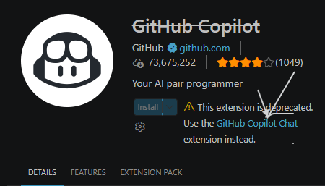
Figure 7

Creating the first mobile app
- Open the terminal in vs code and run “flutter create firstflutterapp”
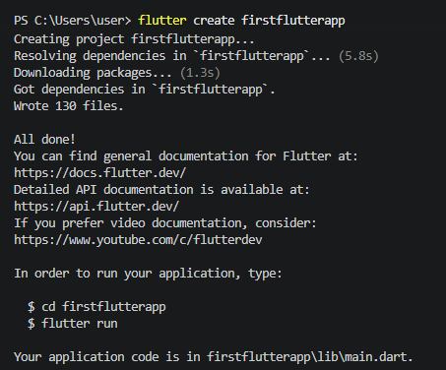
Figure 8
- Then move into firstflutterapp (“cd firstflutterapp”), then open in vs code (“code .”)
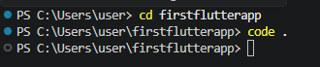
Figure 9
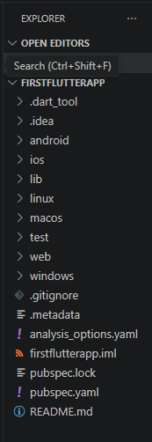
Figure 10
3.Changing the app title, background color and font size (after that we run “flutter run”)
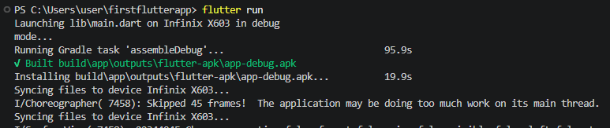
Figure 11
Before | After
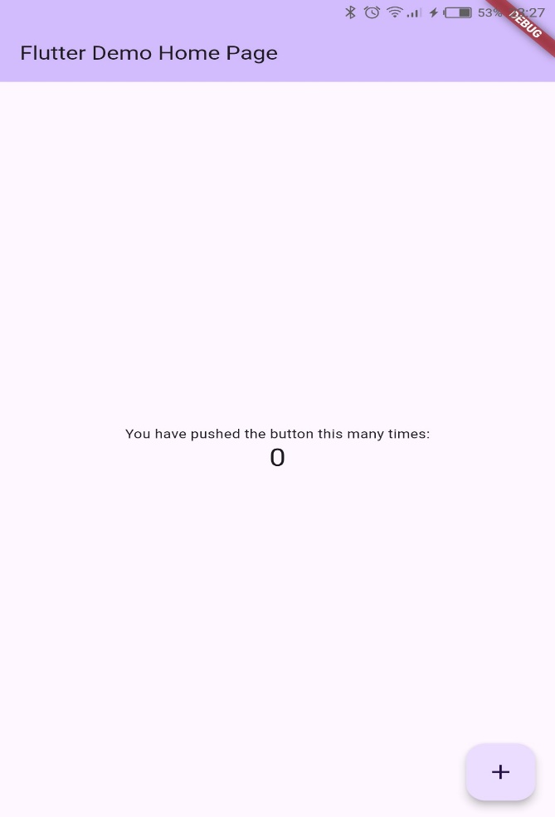  Figure 12 | 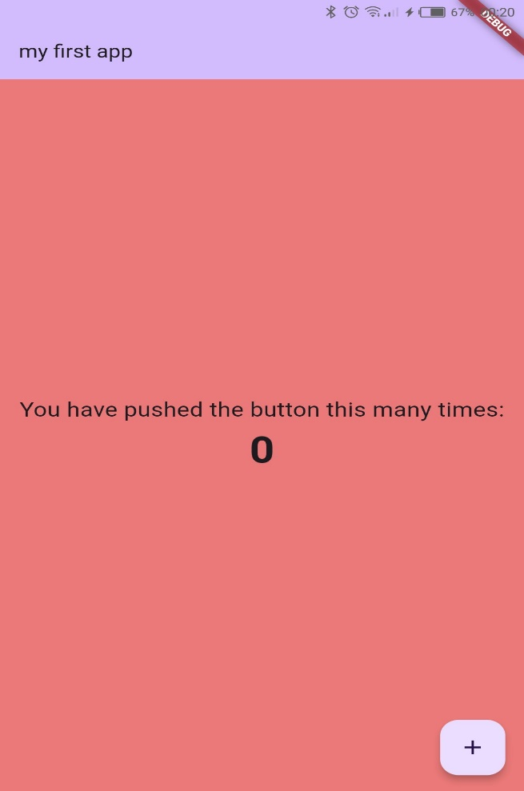  Figure 13

Personal Reflection
This introduction helped me understand the basics of mobile application development and the tools used in the industry. Although setting up the development environment was challenging at first, I learned how to solve configuration issues and successfully created my first Flutter application.

Week 2: Programming Languages and Frameworks

Flutter project (Mini Student Management App)

1.Frameworks(figma)
Registration page | Dashboard
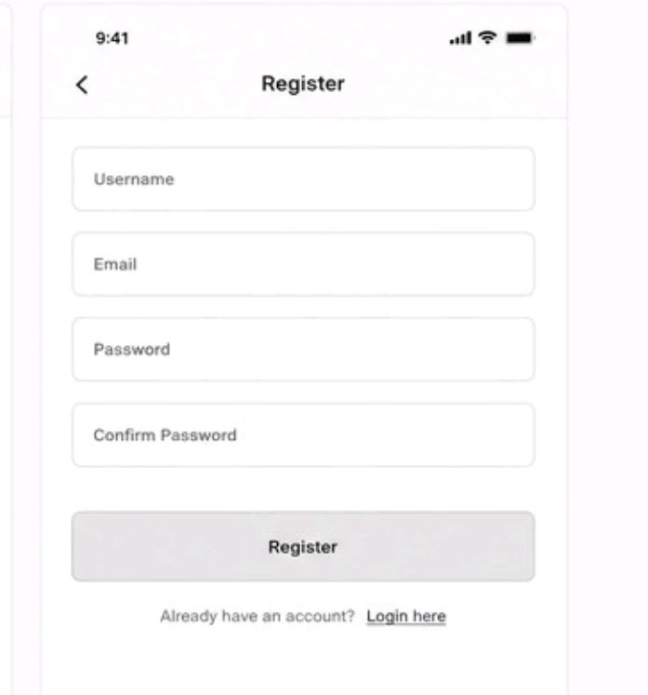  Figure 14 | 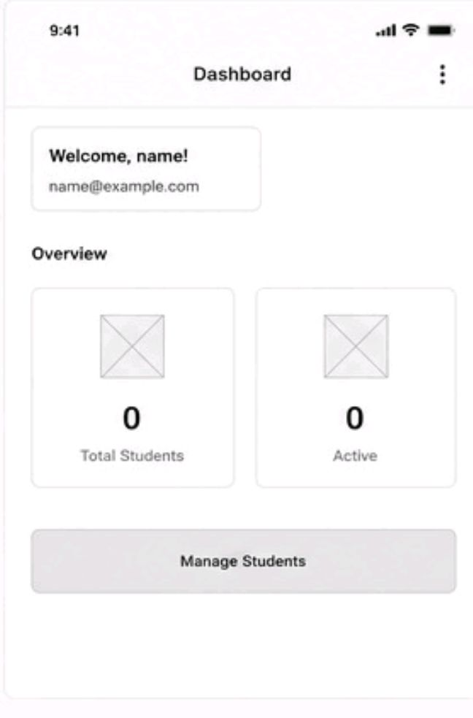  Figure 15

2.Screenshots (Actual App)
Login page | Registration page
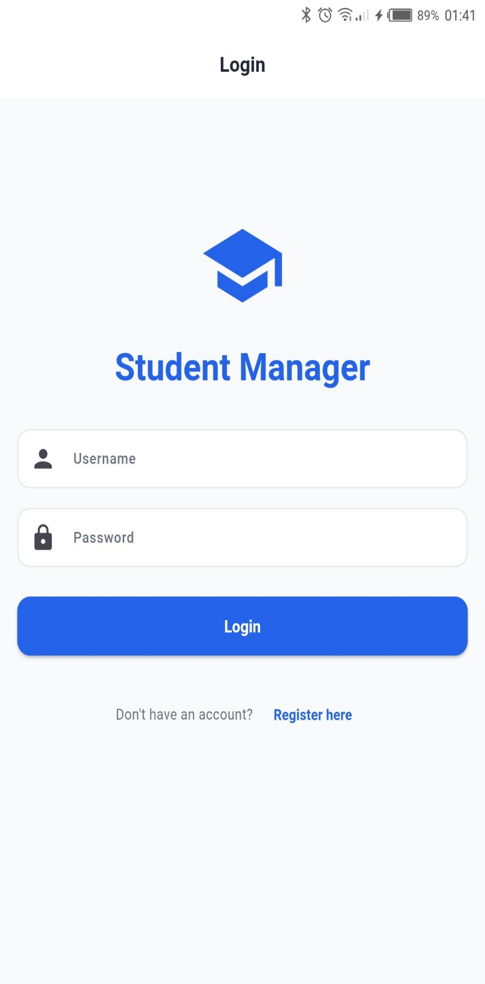  Figure 16 | 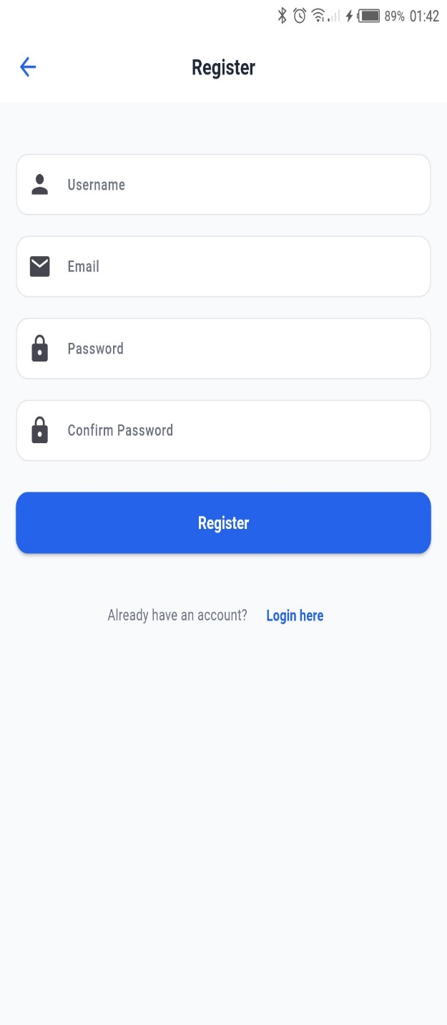  Figure 17

Dashboard
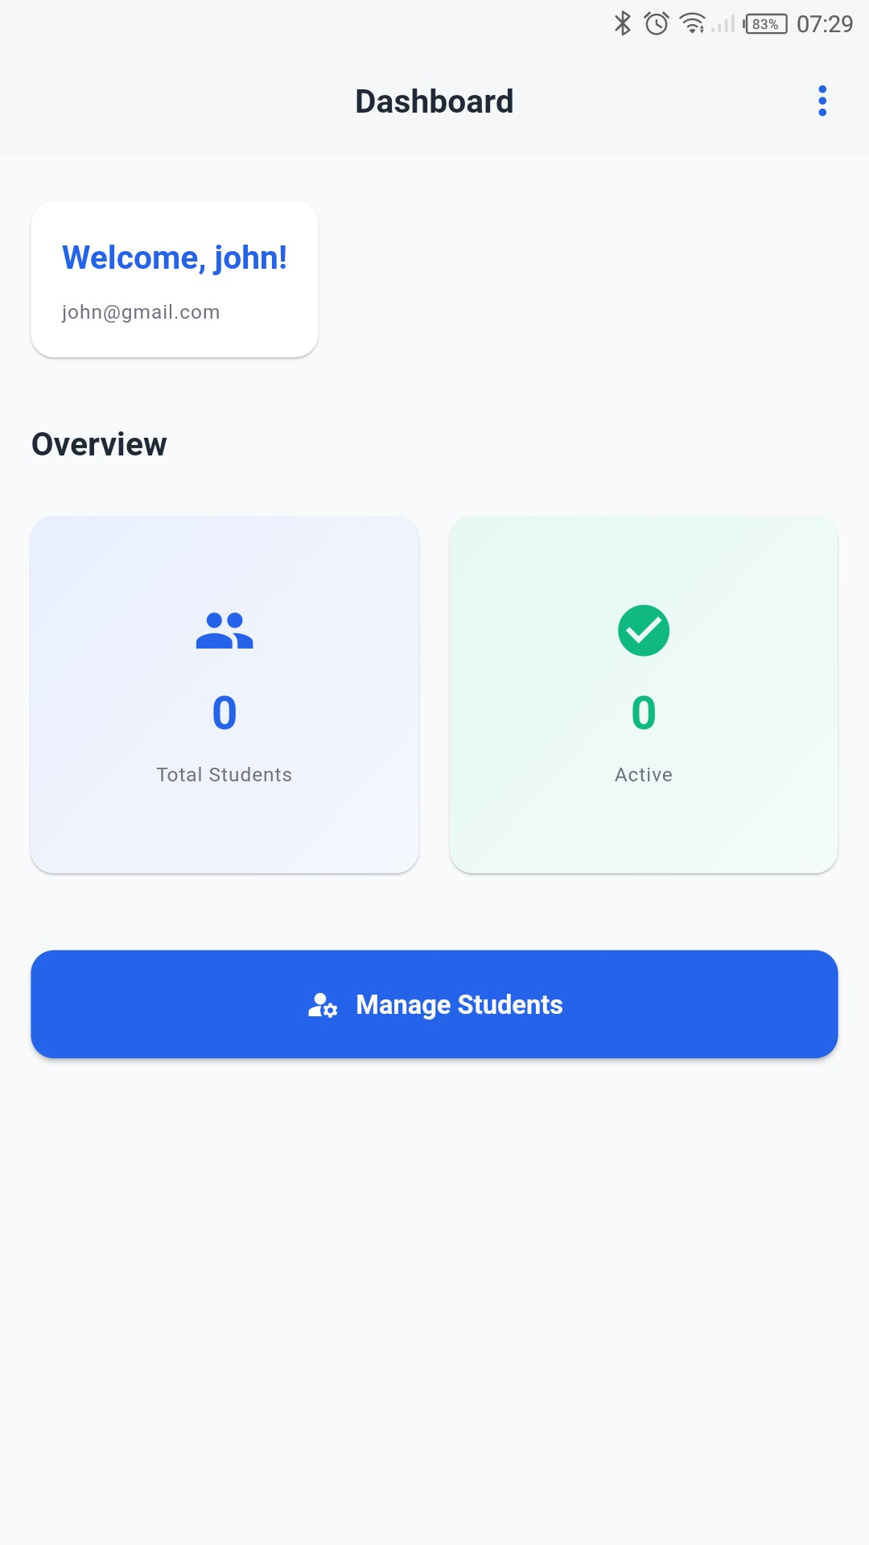
Figure 18

Personal Reflection
I enjoyed learning different programming concepts and applying them in Flutter. Building screens and working with user interface components improved my coding skills. I also gained a better understanding of how databases and APIs can be integrated into mobile applications.

Week 3: User Interface (UI) Development

Building a complete UI

1.Frameworks (figma)
Create an account in figma and start building wireframes.
Login page | Dashboard
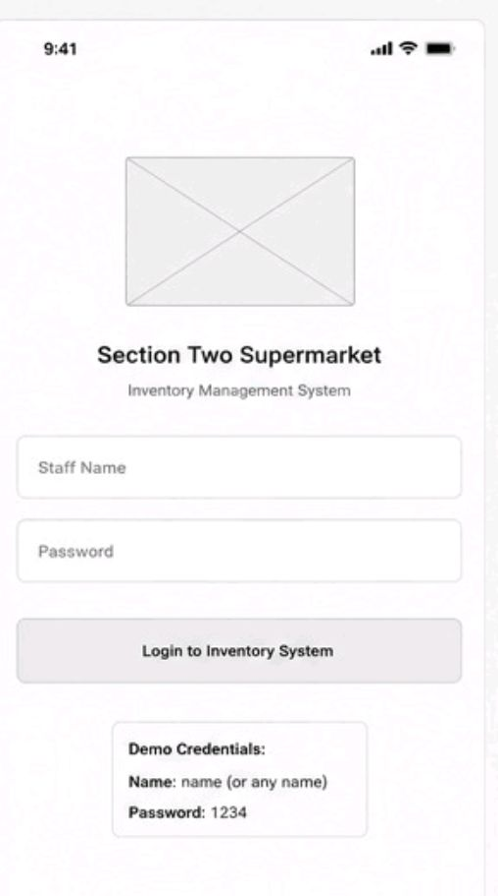  Figure 19 | 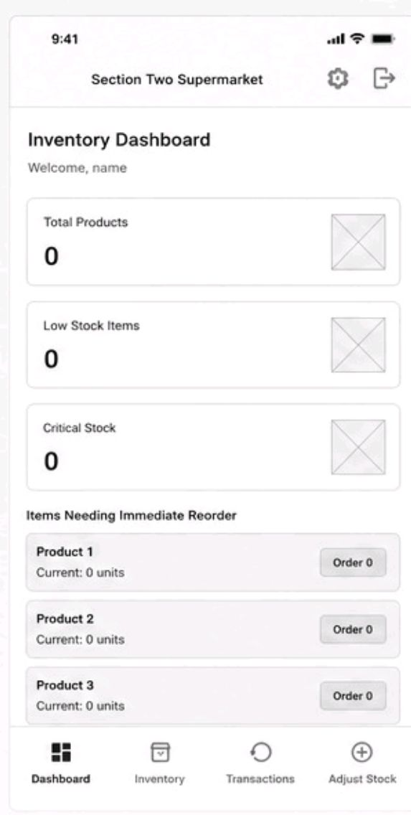  Figure 20
Inventory | Transactions
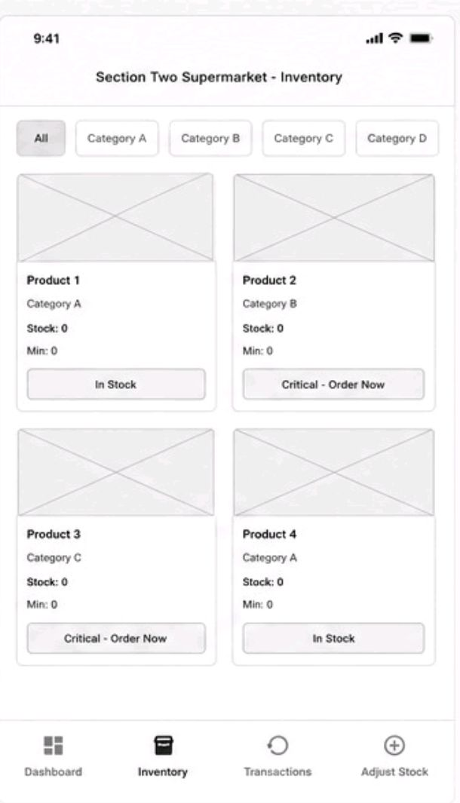  Figure 21 | 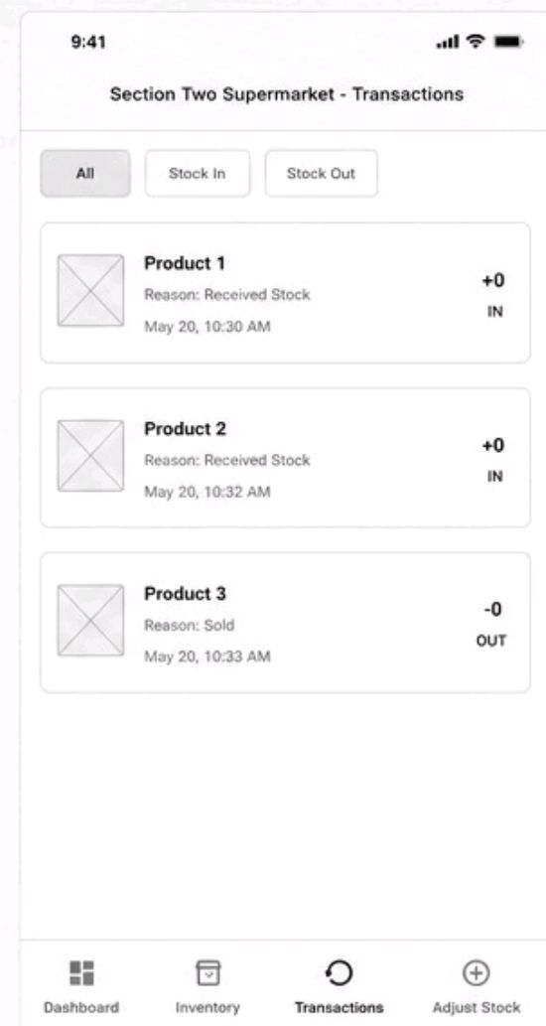  Figure 22

2.Screenshots (Actual App)
Login page | Dashboard
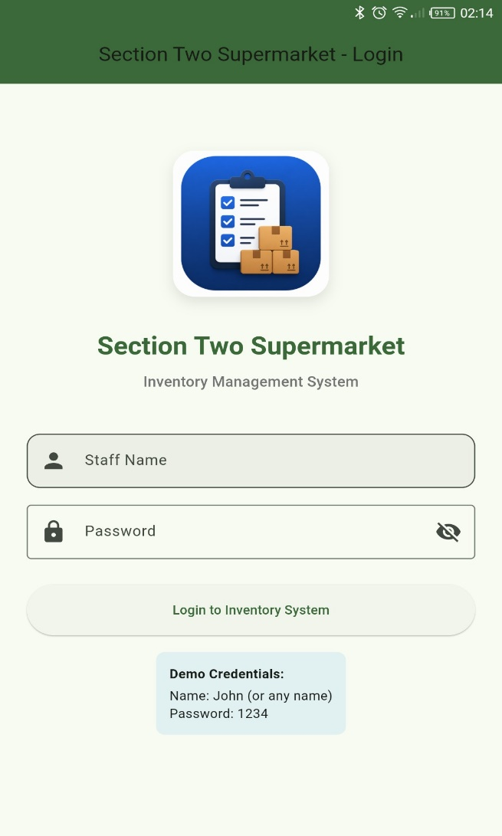  Figure 23 | 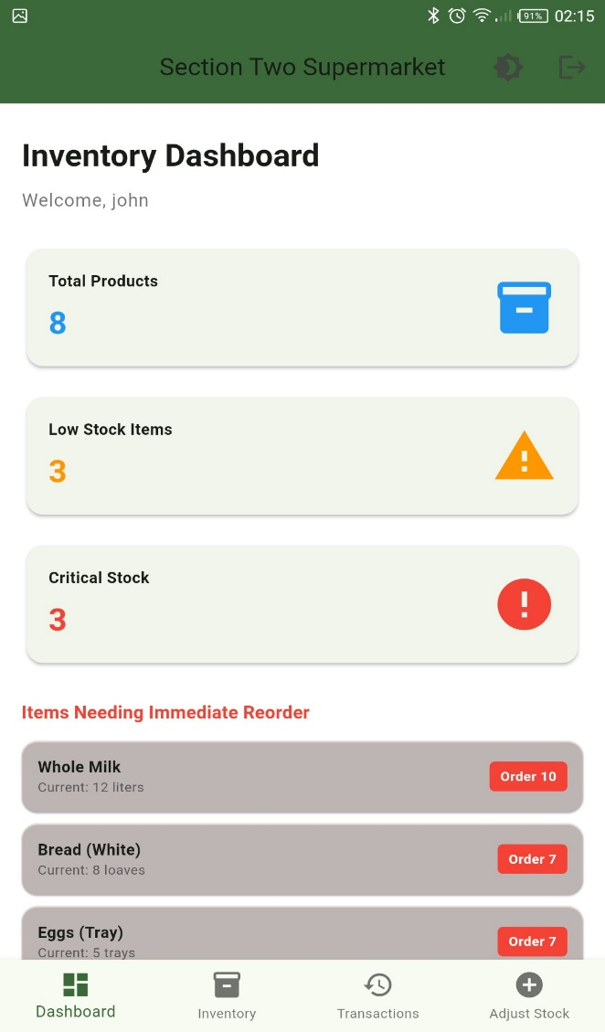  Figure 24

Inventory | Transactions
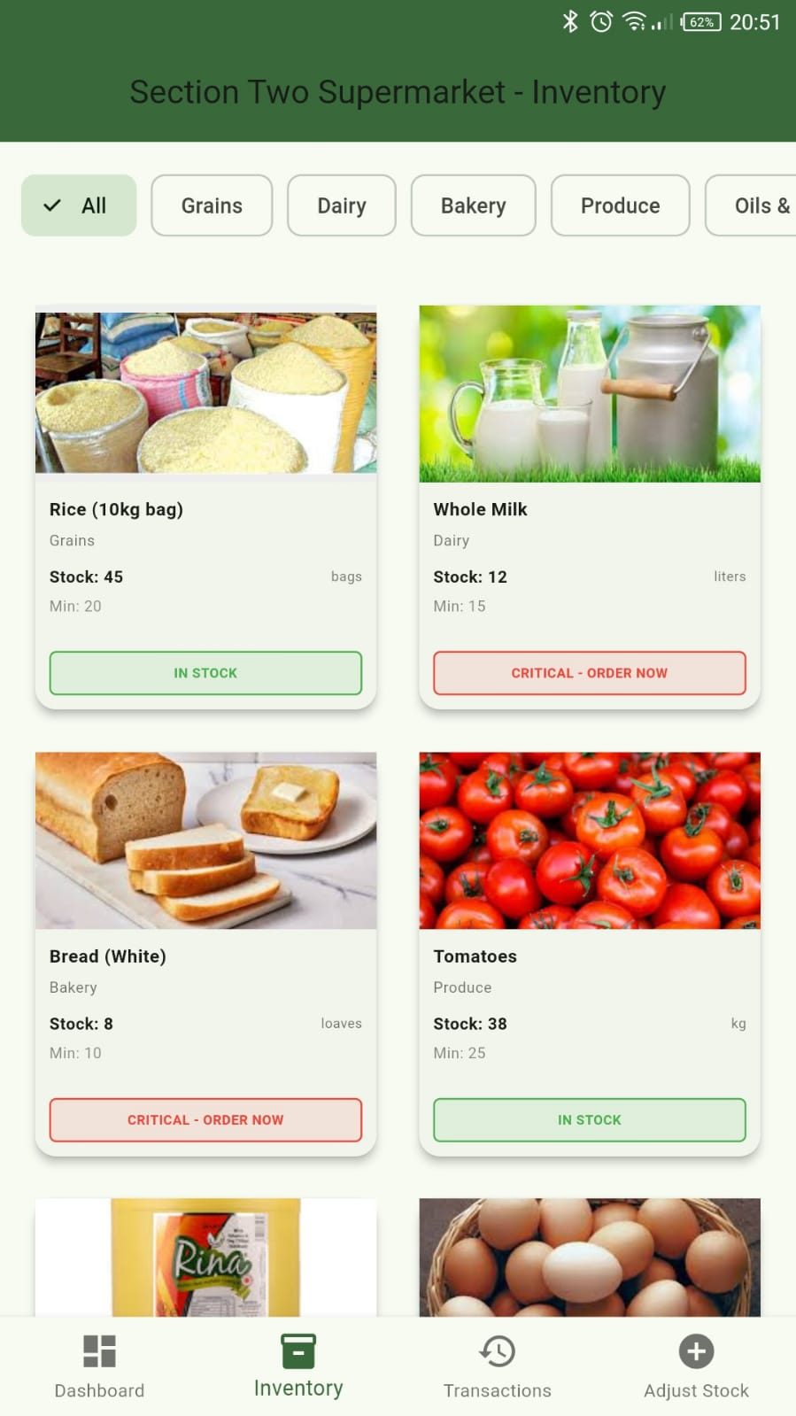  Figure 25 | 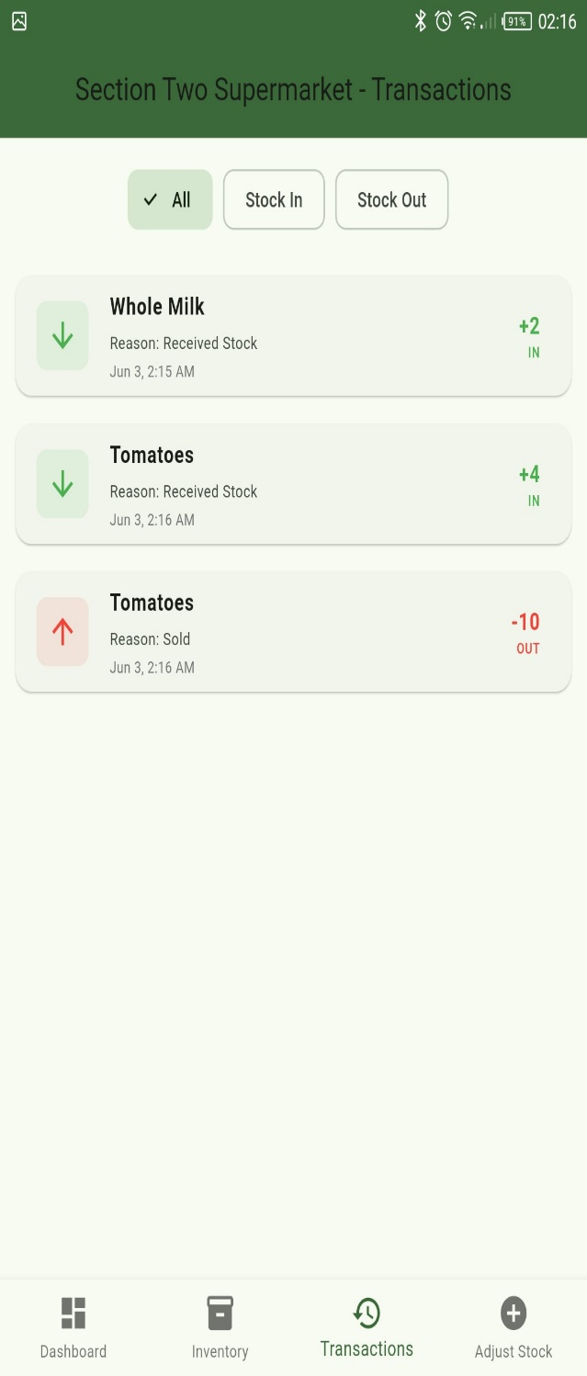  Figure 26
Stock adjustment
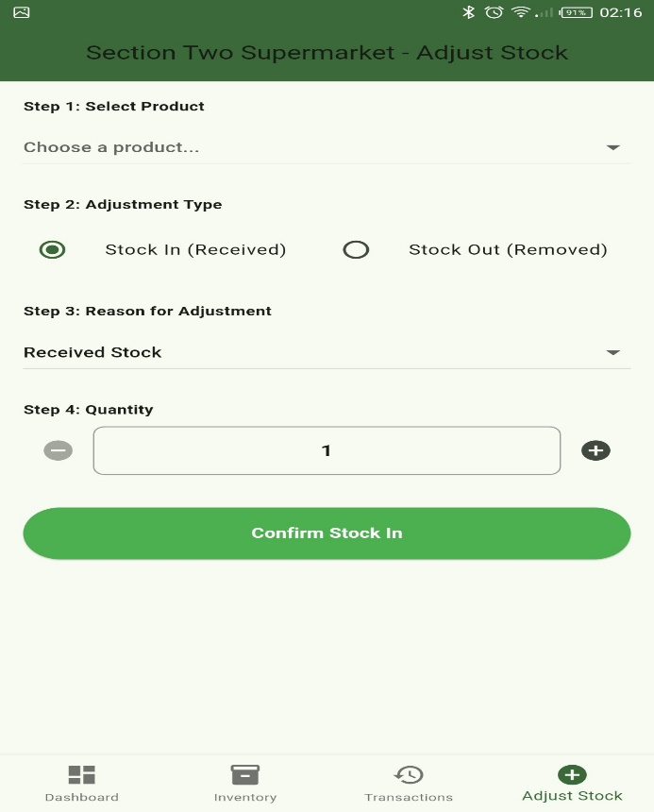
Figure 27

Database Intergration(SQLite)

Figure 28


Figure 29

Firebase
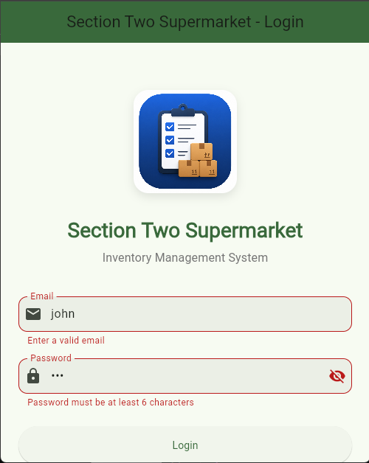
Figure 30
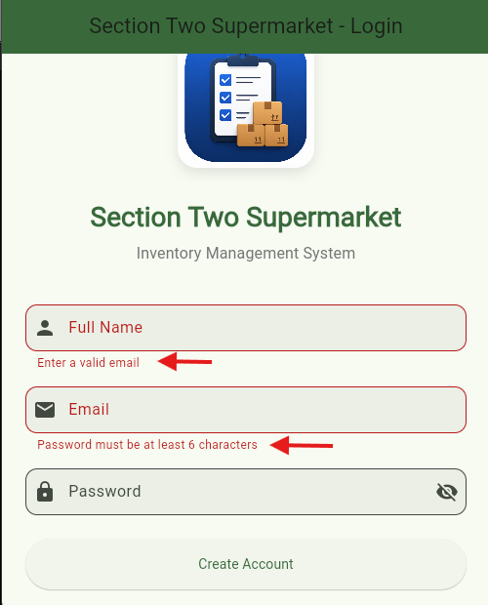
Figure 31

Personal Reflection
I’m able to know the importance of a good UI/UX design. Creating wireframes and turning them into working interfaces helped me appreciate the planning involved in app development. I also improved my skills in designing responsive and user-friendly mobile applications.

Week 4: Event handling and User interaction

Login button
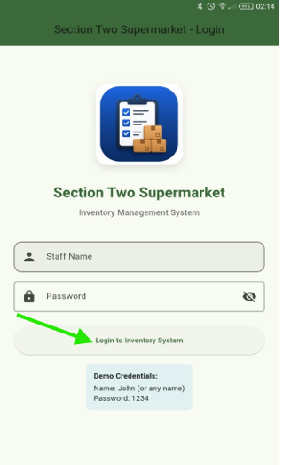

Registration button
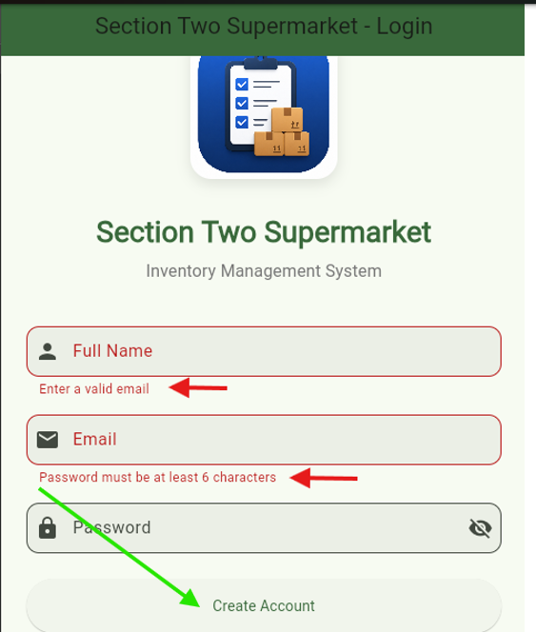

Add button
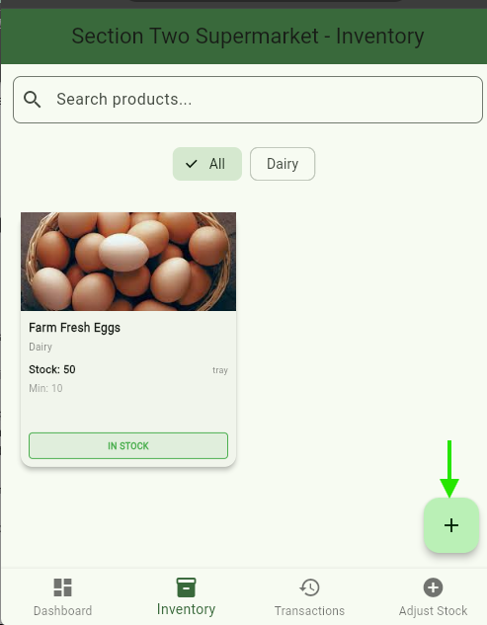

Confirm button
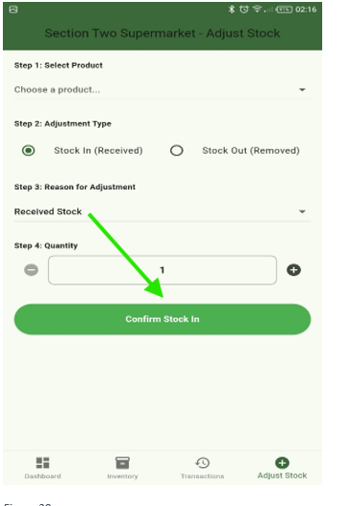

Personal Reflection
Through the buttons, the user is now able to fully interact with the app and navigate through the app. Through this I’m able to make the app user friendly and able to handle events such as ‘click’.

Week 5: Data Management

1.Adding a product/item
  Figure 32 | 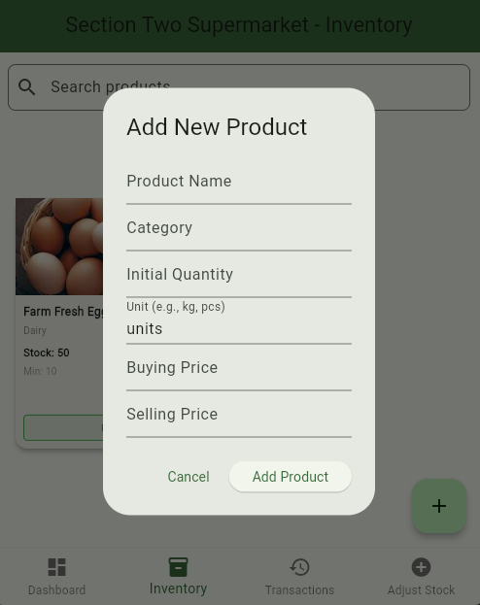  Figure 33

2.Updating product/item quantity

Adding a product
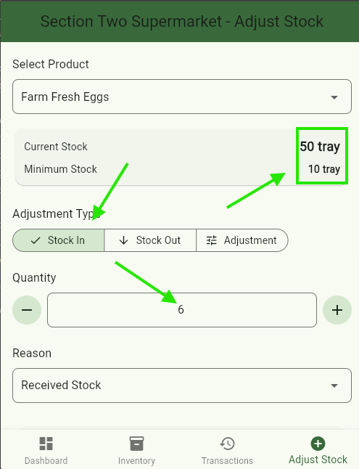  Figure 34 | 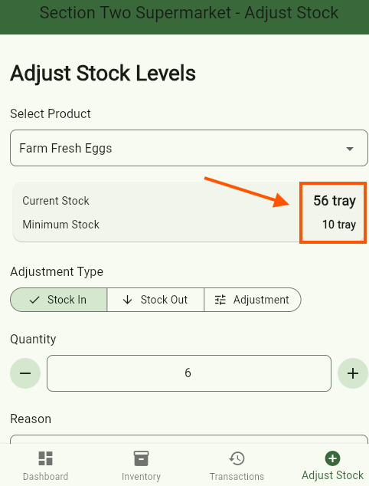  Figure 35

Reducing a product stock
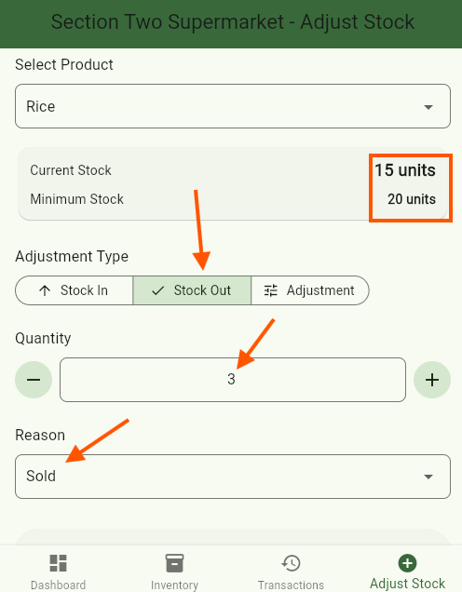  Figure 36 | 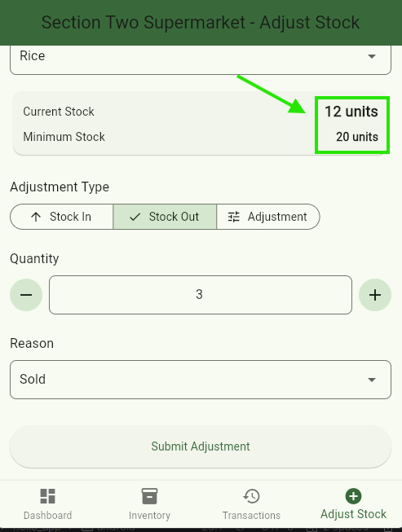  Figure 37

Stored transactions
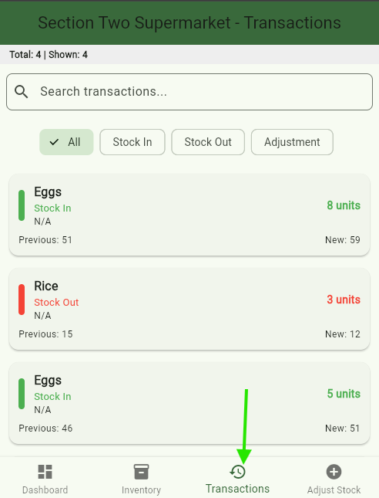
Figure 38

Personal Reflection
I’ve been able to add a button in the inventory page so that a user can add products/items based on his/her business and manage the inventory. I encountered few errors especially on the adjustment of the stock but solved them. Products/items are now stored in the inventory.

Week 6: Networking

Application Launch Interface

Figure 39: Initial mobile application successfully deployed and executed on a physical Android device.

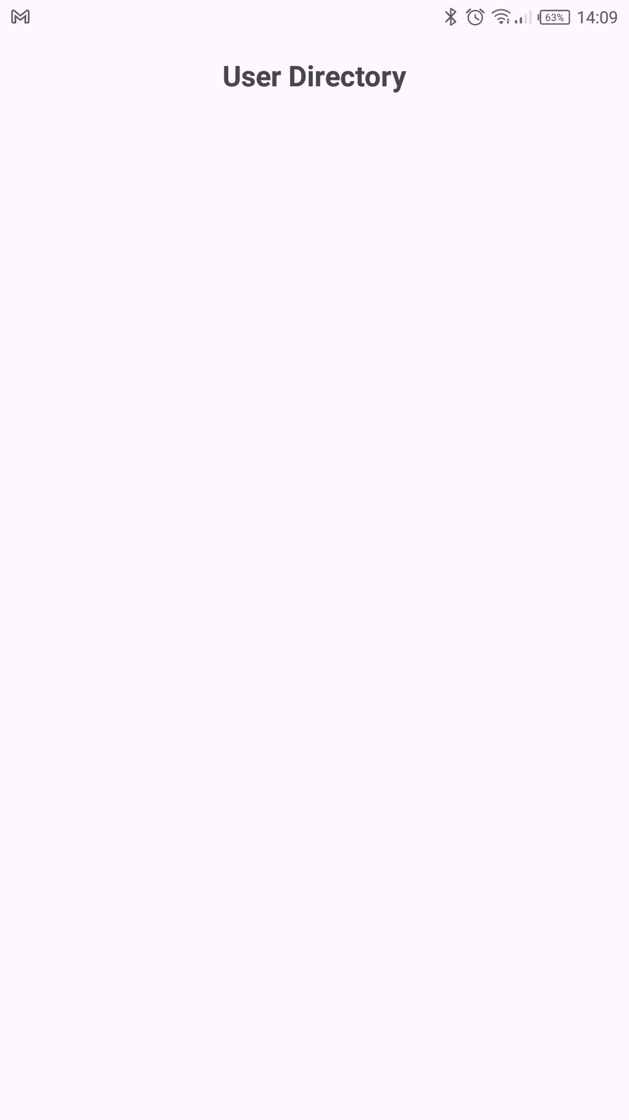
Figure 40: User Directory application interface created to display records retrieved from a REST API.

User Interface Layout Design
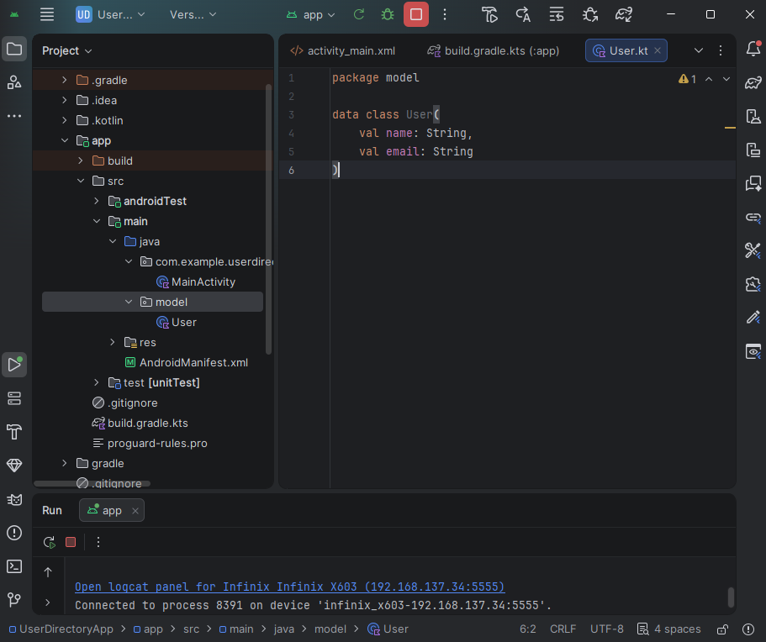
Figure 41: Creation of the User data model used to represent records retrieved from the API.

Item layout design for RecyclerView
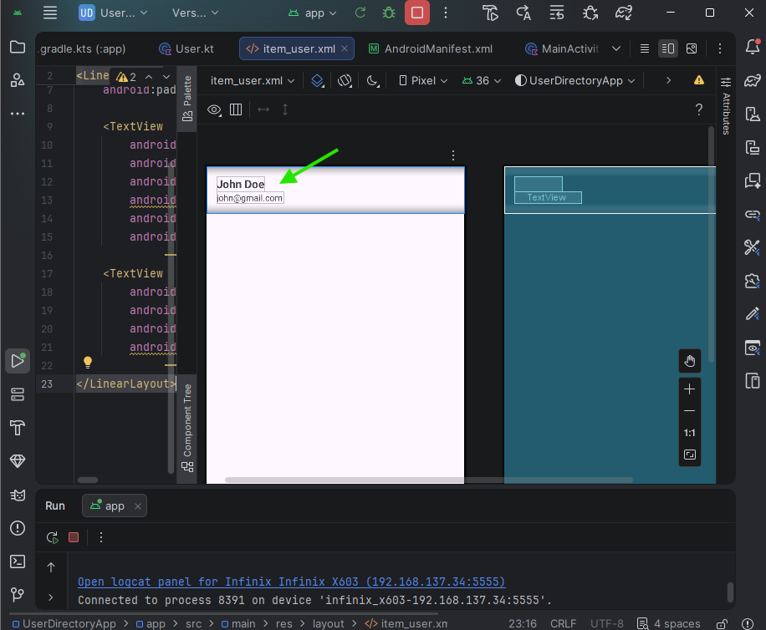
Figure 42 Layout design for individual user records in the RecyclerView.

RecyclerView adapter implementation

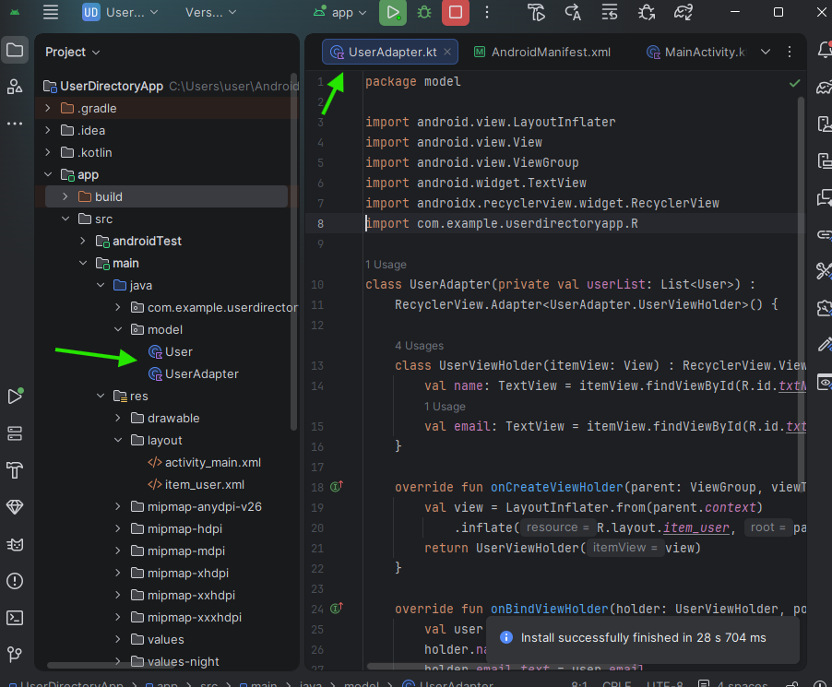
Figure 43mplementation of RecyclerView Adapter for binding user data to the interface.

Local data testing output
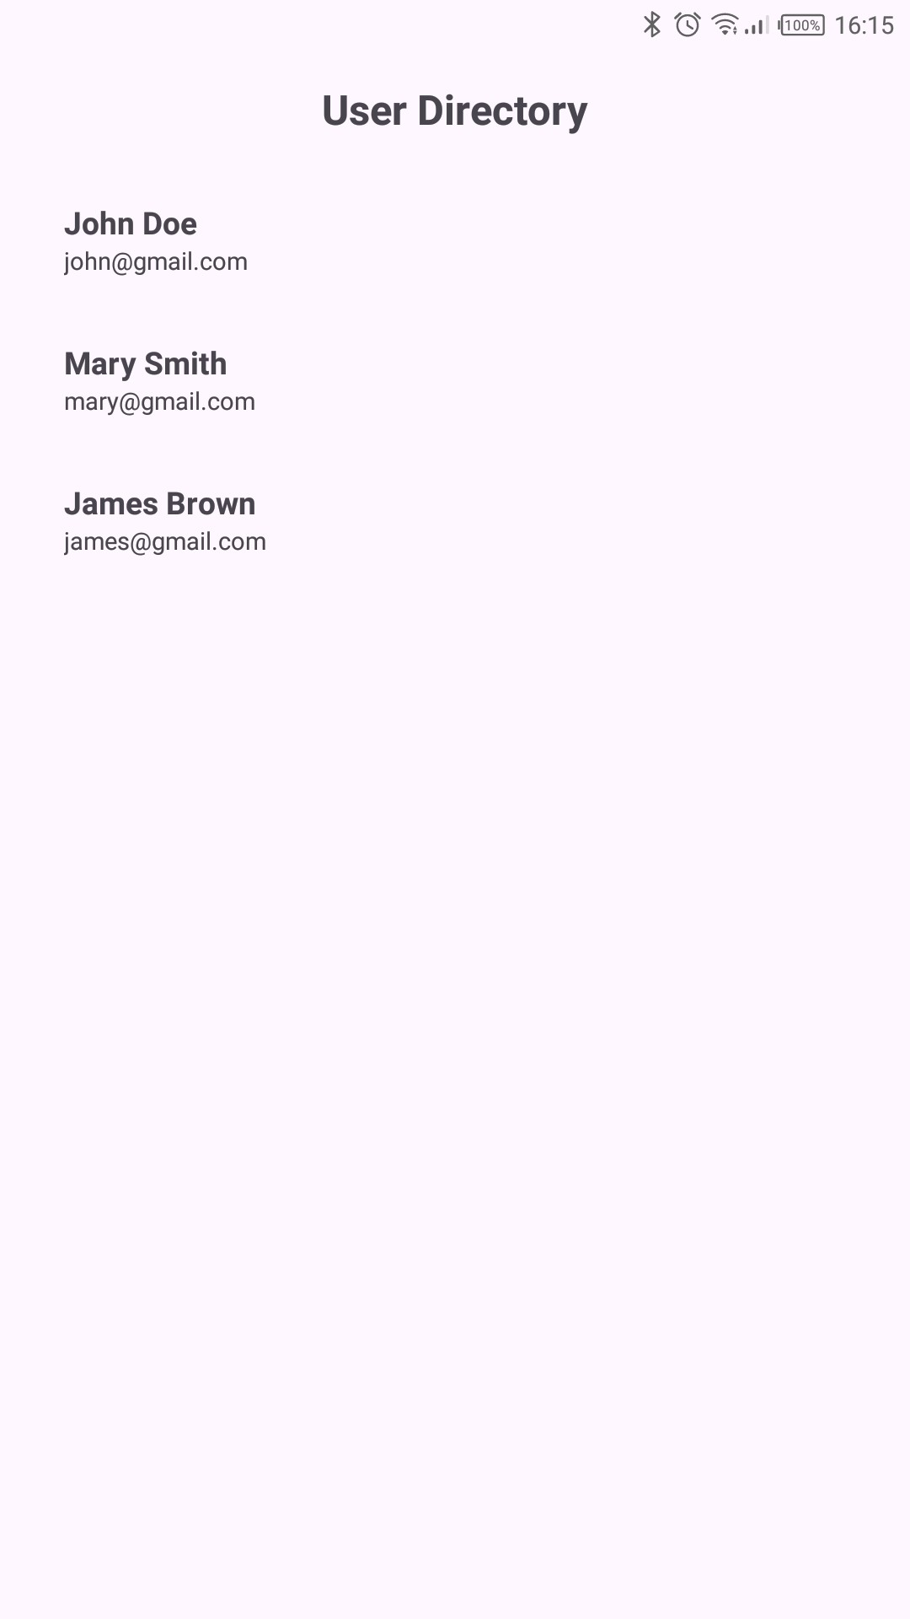
Figure 44: RecyclerView displaying locally generated user data to verify adapter and layout integration

Internet permission configuration
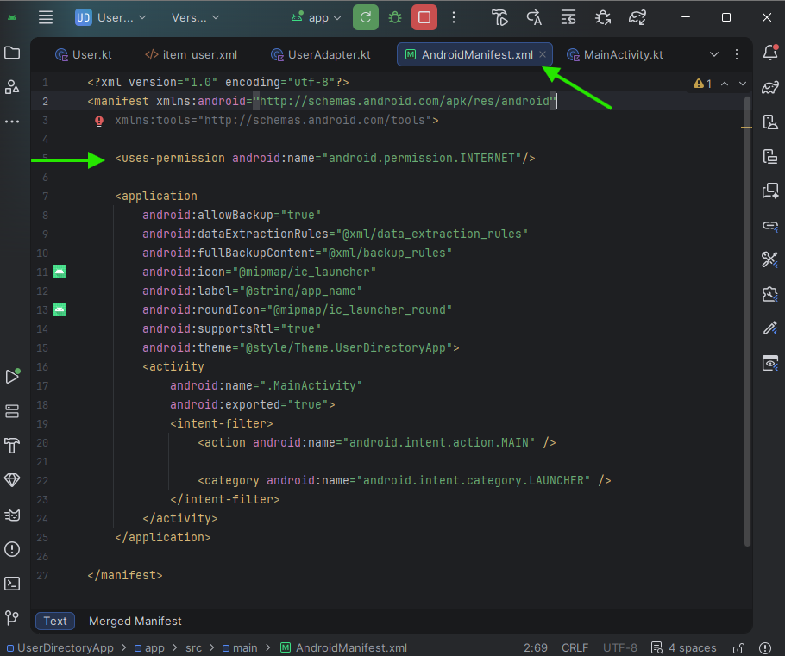
Figure 45: Internet permission added to enable API communication.

Retrofit dependency setup
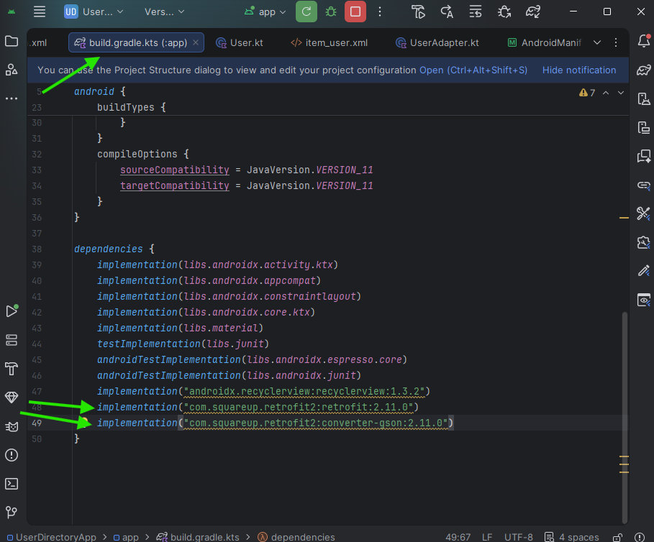
Figure 46: Retrofit dependencies added to enable REST API communication.

API model structure
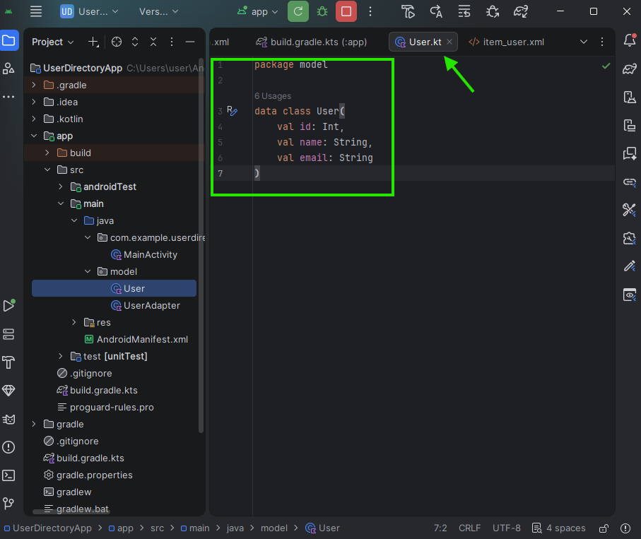
Figure 47: User data model structured to match REST API JSON response.

API interface definition
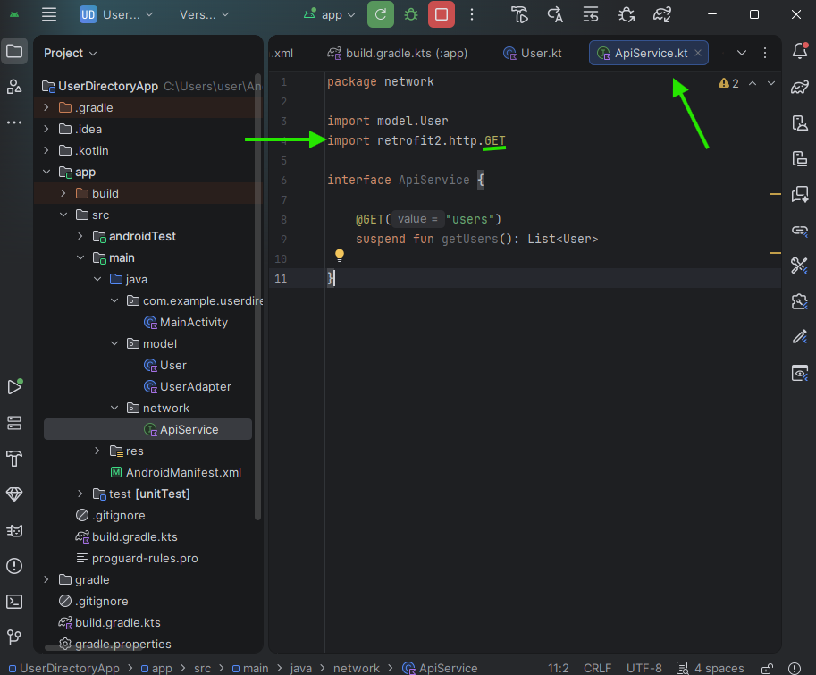
Figure 48: API interface defining HTTP GET request for retrieving user data.

Retrofit Client Configuration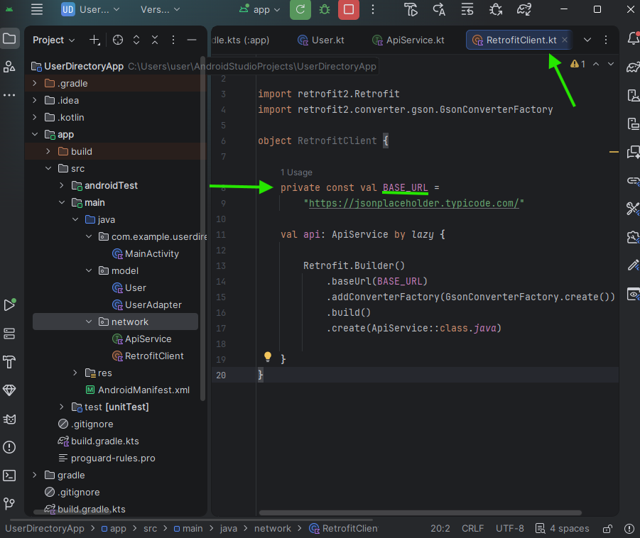
Figure 49: Retrofit client configuration establishing connection to remote REST API.

Asynchronous API Request Handling
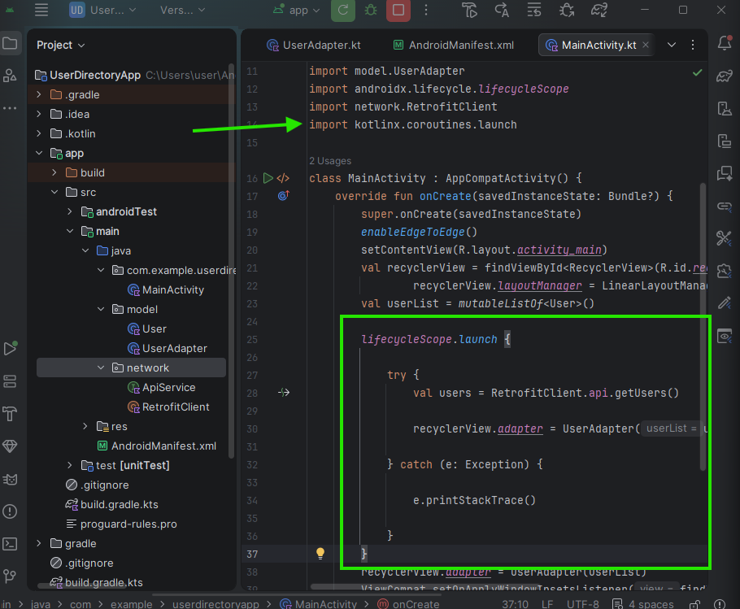
Figure 50in:Main Activity implementation using coroutine to fetch data from API without blocking the UI

Final API data output
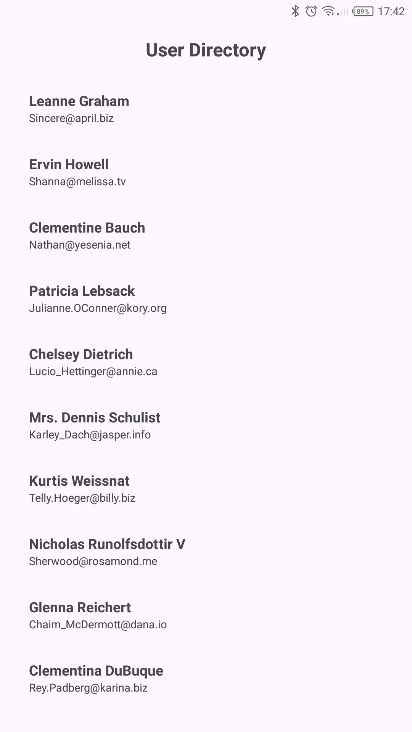
Figure 51: Successful retrieval of user records from a public REST API and display using RecyclerView with asynchronous processing.

Technologies Used
1.Retrofit
2.RecyclerView
3.Internet Permission

Why my app requires networking?
My app requires networking to fetch user data from a remote REST API in real time instead of storing static local data.

Personal Reflection
This week's activities enhanced my understanding of mobile networking, REST APIs, asynchronous processing, and data retrieval from remote servers. I learned how to consume web services and display retrieved information dynamically using RecyclerView.

Week 7: Application architecture
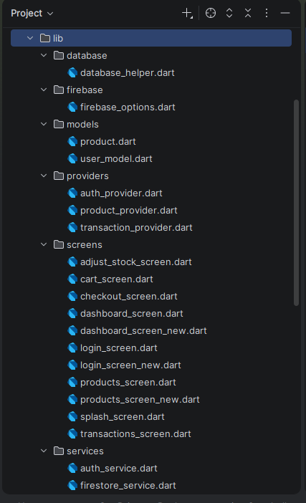

Personal Reflection
I’m able to understand the architecture of this app and organize them accordingly. This was done in the process of creating the app.

